**Client-Side App Rubric** <https://github.com/denisecase/pbl-lifeline-links>

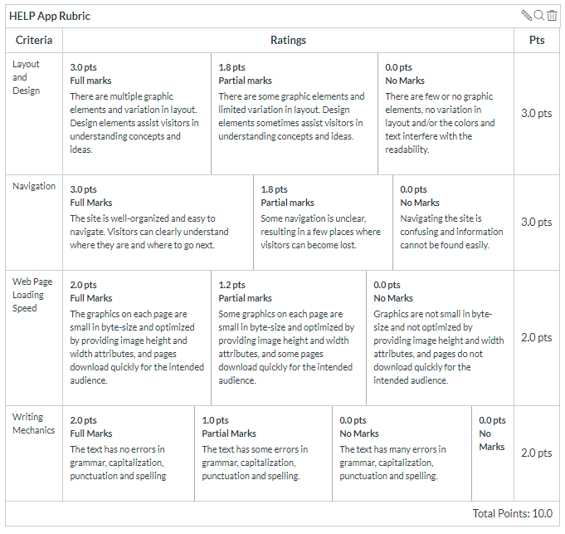

**Team reviewed: Group 01-01**

**Link to the web site:** <https://cweltonsmith.github.io/pbl-website/index.html>

**Layout and Design**

Score: 2.5

Comments: The overall layout works, however it seems pretty baseline being mostly black and white. It’s to the point and gets the point across as quickly as possible. There could be some visual elements that make certain things pop more, but overall, it was decent.

**Navigation**

Score: 2.5

Comments: Whenever using the navigation, the only complaint was wheneer you click on “Home”, “Pricing” and “Contact us” it loads on the same page, however when you click on history, it loads a completely separate page. This can throw some users off when navigating by thinking that everything they will need will be on that one page.

**Loading Speed:**

Score:2

Comments: Nothing took to long to load, however when clicking on the pricing, every once and a while it would take a few seconds to load. It only happened once or twice, so it may have been an internet error.

**Writing Mechanics:**

Score: 2

Comments: There were no known grammatical errors noticed.

**General remarks:**

**Overall, the site loaded fine. The issue with the nav loading a different page may be displeasing, potentially it would be a smart idea to try to either move it to separate pages, or move the history to the same page. That would help with things being more fluent throughout and bring the site together even more.**

**Review performed by:**

**Ricky Calderon**

**Aaron Stahl**

**Date and time performed: 12/5/2019 12:44**